Let’s Build the Cloud, One Server at a Time!

GHC-2018 WORKSHOP QUIZ

A) QUIZ

1. What does DIMM stand for?

*(a) Dual In-Line Memory Module (b) Digital Intermediate Memory Manager*

*(c) Digital In-Line Memory Module*

2. A DIMM is a memory module that contains one or more RAM chips on a small circuit board with pins that connect directly to the motherboard. True or false?

*(a) True (b) False*

3. What does **BIOS** stand for?

*(a) Base Input/Output System (b) Basic Input/Output System*

*(c) Backup input/Output System*

4. __________ is a program that is stored on a chip on the motherboard and helps load the operating system.

*(a) BIOS (b) Firmware*

*(c) RTOS*

5. What is a processor's clock cycle?

*(a) Amount of time between two pulses of an oscillator*

*(b) A single increment of the processor's clock*

*(c) All of the above*

6. A processor's clock speed is measured in Hz, typically in gigahertz (GHz). A 5GHz processor performs how many clock cycles per second?

*(a) 5,000,000 (b) 5,000,000,000*

*(c) 5,000,000,000,000*

7. The air baffle in a server re-directs the flow of air such that heated parts can be kept cooler. True or false?

*(a) True (b) False*

8. Which hard drive type delivers the best performance and speed?

*(a) SATA (b) SAS*

*(c) SSD*

9. 1 Gigabyte (GB) = 1024 MB. 1 Terabyte (TB) = 1024 GB. 1 ______________ = 1024 TB.

*(a) Petabyte (PB) (b) Exabyte (EB)*

*(c) Zettabyte (ZB)*

10. Which of the following is true about SSD drives?

*(a) No moving parts unlike traditional spinning media hard drives*

*(b) Use flash memory to store data*

*(c) All of the above*

11. ______________ is a communications protocol optimized for flash based storage devices, delivering high speeds and low latencies.

*(a) SAS (Serial Attached SCSI) (b) NVMe (Non-Volatile Memory Express)*

*(c) SSD (Solid State Drive)*

12. Components such as fans and power supplies are referred to as FRUs. What does FRU stand for?

*(a) Field-Replaceable Unit (b) Field-Removable Unit*

*(c) Field-Reliable Unit*

13. PCI is a bus standard for attaching expansion cards to the system board. What does PCI stand for?

*(a) Processor Component Interconnect*

*(b) Programmable Component Interconnect*

*(c) Peripheral Component Interconnect*

14. PCIe is now the standard that supersedes the older PCI standard. PCIe has several improvements over PCI such as higher throughput, better performance, smaller physical footprint, etc. What does the 'e' in PCIe stand for?

*(a) Express (b) Enhanced*

*(c) Extended*

15. A "Rack Unit" (abbreviated as U) is a unit of measurement of height of equipment that mounts into a server rack. Each rack unit (1U) equals 1.75 inches. Could you guess the height of the server you worked on in U's?

*(a) 1U (b) 2U*

*(c) 3U*

B) PUZZLE

Solve the below Anagrams and then find the actual word in the puzzle below

VERSER

CARK

INUT

SHASCIS

TCRENETDAA

WREOP

TWERONK

TESHWISC

MCANEROPFRE

REOMYM

RPECOSOSR

GEOSATR

LUDOC

PTMUECO

FYCIFENCEI

CSLEA

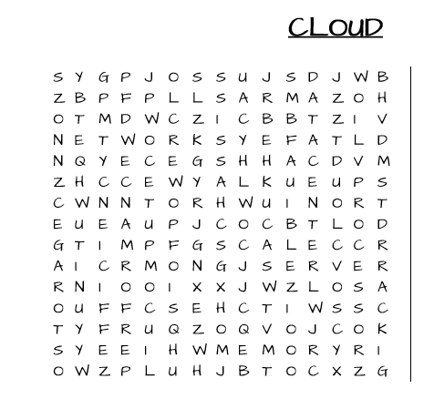

1. Answers

*1(a), 2(a), 3(b), 4(a), 5(c), 6(b), 7(a), 8(c), 9(a), 10(c), 11(b), 12(a), 13(c), 14(a), 15(a|b)*

B) Answers

SERVER,RACK,UNIT,CHASSIS,DATACENTER,POWER,NETWORK,SWITCHES,PERFORMANCE,MEMORY,PROCESSOR, STORAGE,CLOUD,COMPUTE,EFFICIENCY,SCALE